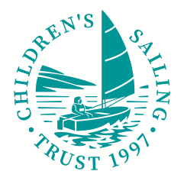
Children’s Sailing Trust
Golf Day at Budock Vean
Friday 10 September 2021
Your name:
Contact number: Email address:
Would you like to be kept up to date with Children’s Sailing Trust by opting in to emails? Y/N
Team members:
Name: Handicap: BVGC member? Y/N
Name: Handicap: BVGC member? Y/N
Name: Handicap: BVGC member? Y/N
Name: Handicap: BVGC member? Y/N
Are there any vegetarians, vegans or anyone with dietary requirements?
Are there any accessibility needs we can assist with?
Payment options:
£20 Budock Vean Golf Club members, £30 non-members
Please send completed form in an email to justine@childrenssailingtrust.org.uk and make a Bank Transfer with a reference code: 2021Golf_YourName to bank details:
Children’s Sailing Trust 16014060 / 30-98-90 Lloyds Bank
Or
Send this form with a cheque made payable to Children’s Sailing Trust to Children’s Sailing Trust, Stable Court, Mawnan Smith, Falmouth TR11 5JZ with 2021 Golf Day written on envelope.

Children’s Sailing Trust, Stable Court, Mawnan Smith, Falmouth TR11 5JZ
Tel: 01326 702326 | www.childrenssailingtrust.org.uk | hello@childrenssailingtrust.org.uk

